**Section 3 - Popularization of the Rotary Engine**

**3.1 Rising to Stardom**

In 1959, following further development the Wankel engine was shown to the public. Manufacturers from General Motors to Daimler-Benz and Toyota desperately attempted to gain rights to build the technology and the world of vehicular manufacturing was excited to experiment with this design.

*"Thirty-four of the companies that applied for those rights were from Japan, but in 1961, the sole Japanese license was awarded to Toyo Kogyo Kaisha Limited"*

Toyo Kogyo was later renamed Mazda Motor Corporation. The Wankel engine was then known as the rotary, and every other carmaker eventually halted on its development.

For road use, the design results in many engineering challenges, such as:

* Fuel Thirst
* Oil Consumption
* Low Torque

But Mazda has continued its journey with adopting its design for almost fifty years. The company built its first rotary road car in 1967 (Cosmo Sport). Therefore, it was this surrounding culture of racing and passion for cars that allowed rotary to "pick up" in popularity. Furthermore, it would be introduced into the world of motorsport racing.

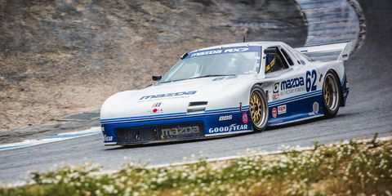

*Figure 1 -*1990 MAZDA RX-7 IMSA GTO

[Image Source](https://www.roadandtrack.com/car-culture/a10347460/the-glory-of-mazdas-experimental-rotary-race-cars/)

**3.2 Car Culture**

The RX-7 was a car that pierced the "consciousness of the general public" and more importantly, allowed Mazda’s reputation for sports cars. The name stood for Rotary Experiment 7 - hinting at the ongoing experimentation with the rotary that was to come.

The first RX-7 was introduced in 1978 and was a small, rear-wheel sports car, powered by an engine called the 12A.

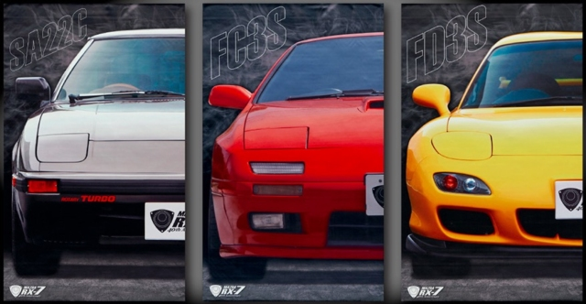

*Figure 2 - RX-7s of the Past*

*RX-7 'SA22', 'FC3S', and 'FD3S' Generations*

[*Image Source*](https://japanesenostalgiccar.com/japan-post-celebrates-40th-anniversary-of-mazda-rx-7-with-exclusive-rotary-goods/)

Note: RX-7s famously had a cockpit warning buzzer near

redline (or high RPMs) due to the engine being quiet and operating smoothly - engineers required a way to warn people in a case they would forget to shift.

These sports cars of the early 70s (similar to the early generation RX-7s) always had their niche popularity and appeal to primarily male, wealthy demographics. However during the launch of these vehicles, the design and engineering behind the vehicles (especially those from the Japanese market) allowed for the working class and younger generation to afford these vehicles. No longer where sports cars limited in choice. No longer would potentially high-performance vehicles be limited to the wealthy. Furthermore, everyone within society were not limited to British, American and European sports cars, there was a new market - the introduction of the **Japanese Domestic Market (JDM).** This meant that the choices people had increased and those that could own/afford a sports car also increased. The JDM also opened expanded its horizons and exported such cars into western markets.

Furthermore, with the door opened to more people being able to own such vehicles car culture arose within the vehicle industry and people began to experiment. People with a passion for cars expanded the small industry and culture of car modification, stemming from Japan itself. Furthermore, the publication of games, movies and television, depicting the iconic rotaries and JDM vehicles popularized the car industry. People consumed and so the rotary continued with Mazda's iconic cars being boosted in popularity through pop-culture, forcing them to experiment more with the rotary.

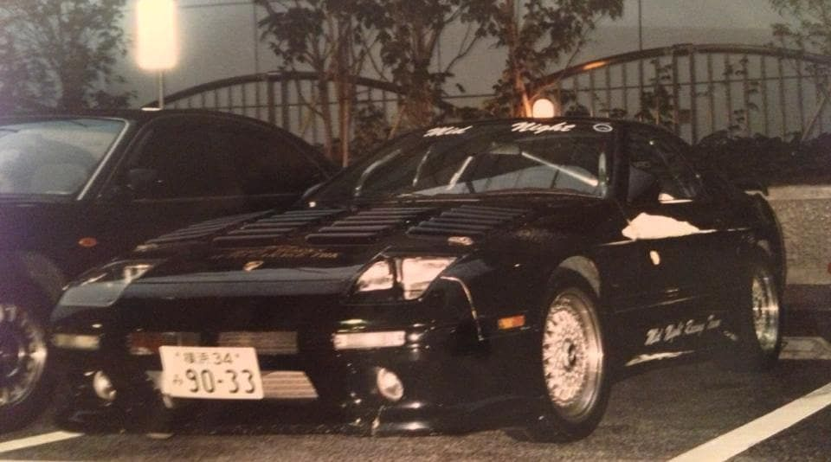

*Figure 3 - RX-7 FC*

[*Image Source*](https://www.pinterest.com.au/pin/572168327634425828/)

**3.2.1 Pop-Culture**

With the rise of technology and communication in the late 20th and 21st century, car culture began to grow as various companies similar to Mazda impacted a growing community of those passionate for cars in general. This includes various media groups and outlets that revolve around the street and aim to share information and modifications toward the amateur culture for car lovers. For example, **speedhunters**, **stancenation** and **veilside**, just to name a few closely associated to Mazda and rotary model vehicles. The rotary grew popularity through this communities and the rotary, therefore, was shown in some of the following types of media, boosting its popularity through the idolisation specific cars from Mazda received.



*Figure 4 - Example of RX-7 Community Builds & Modification*

[*Image Source*](http://www.speedhunters.com/2018/10/taking-the-time-to-build-an-rx-7-the-right-way/)

Furthermore, movies such as the Fast and Furious series had various icon rotary engine vehicles that impacted and grew the culture around cars and specifically the rotary engine. Alike the same can be said for popular video games such as Need for Speed around 2003.

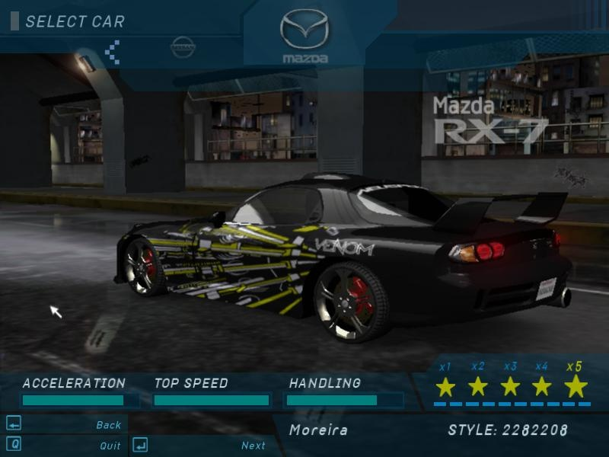

*Figure 5 - Need for Speed Underground (2003)*

[*Image Source*](https://www.nfscars.net/need-for-speed-underground/5/showroom/list/car/mazda-rx7/8/)

**

*Figure 6 - Fast & Furious Tokyo Drift - Veilside Body Kit RX-7*

[*Image Source*](https://fastandfurious.fandom.com/wiki/1997_Mazda_RX-7)

**3.3 Motorsport & Racing**

Mazda has had great success with the rotary engine in the world of motorsport racing, specifically with two, three and four rotary vehicles. With engines having two rotors intended for racing has been developed for high-rpm applications. This simple evidence of how throughout the initial design of this engine, the influence of racing pushed fourth the boundaries of engineering involved with around the rotary. Furthermore, using a 'multi-piece eccentric shaft' (depicted in *figure 7*) allowed for additional bearings between rotors - increasing complexity of the design, however, would be ideal for performance enhancement required around situations in racing.

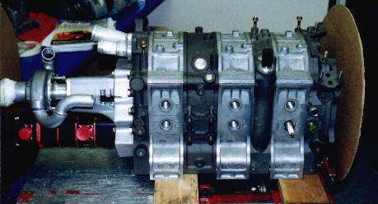

*Figure 7 - 3 Rotor Engine (Mazda Example - 20B)*

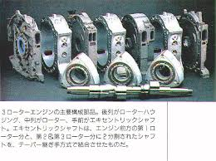

*Figure 8 - Rotary Engine Housing, Rotor and Multi-Piece Eccentric Shaft*

[*Image Source*](http://cp_www.tripod.com/rotary/pg20.htm)

**3.3.1 Future of Rotary in Racing**

The RX Vision is an example of a generation of future sports and racing vehicles from Mazda that are employing a developed and renewed design of the rotary engine.

One of the distinct features being the long and almost impossible low hood is an aspect made possible in a very aerodynamic vehicle design able to be achieved thanks to the compactness of the rotary engine.

Power comes from a SKYACTIV-R rotary engine, which is a combination of Mazda's recent SKYACTIV technology (that increases fuel efficiency and performance) with the sporty power output of a rotary. Mazda is staying secretive about the details of this new engine. It has been rumoured by Mazda that the engine "will be the car’s main power unit, and that it will be more powerful and efficient than any previous rotary."

*(The Visionary - Mazda RX-Vision Rotary Concept - Inside Mazda, n.d.)*

Kiyoshi Fujiwara, Mazda’s R&D boss, says: “We have further developed the materials used for the rotary tips and seals. The engine will undergo a development process that is two or three times as intensive as our other SKYACTIV engines.”

*(The Visionary - Mazda RX-Vision Rotary Concept - Inside Mazda, n.d.)*

*Embedded Video 1 - RX-Vision Concept Rotary Engine Vehicle (Street Model)*

[Video Source](https://www.youtube.com/watch?v=RtIMN6O_izI)

**References:**

[1] - Hsu, B., 2018. *Japan Post celebrates 40th anniversary of Mazda RX-7 with exclusive rotary goods*. [online] Japanese Nostalgic Car. Available at: <https://japanesenostalgiccar.com/japan-post-celebrates-40th-anniversary-of-mazda-rx-7-with-exclusive-rotary-goods/> [Accessed 9 May 2021].

[2] - Rotaryracecars.com.au. n.d. *Rotary Race Cars – rotary engine performance*. [online] Available at: <http://www.rotaryracecars.com.au/> [Accessed 9 May 2021].

[3] - Smith, S., 2018. *The Glory of Mazda’s Experimental Rotary Race Cars*. [online] Road & Track. Available at: <https://www.roadandtrack.com/car-culture/a10347460/the-glory-of-mazdas-experimental-rotary-race-cars/> [Accessed 9 May 2021].

[4] - Inside Mazda. n.d. *The Visionary - Mazda RX-Vision Rotary Concept - Inside Mazda*. [online] Available at: <https://insidemazda.mazdausa.com/the-mazda-way/the-people-behind-mazda/rx-vision-rotary-concept/> [Accessed 9 May 2021].